PS-IT2120

LABSHEET05

IT24103583

Exercise

1. 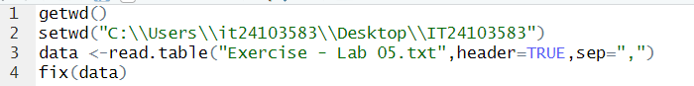

2.

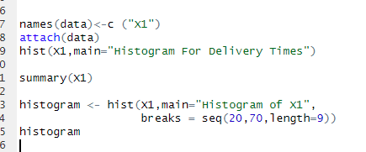

3.

Bi-Model shaped

4.

